System Verification CuteSat
- temperature, humidity and pressure sensors work (we received reasonable data)
- At room temperature: about 13100 and 10700 when warmed
- Lat 78,222443 long 15.651890 Alt 29.2m having about 10 satellites after 2 or 3 min (first started with about 36m)
- Rotation, pitch and yaw change as expected. Pitch is negative for the tip of cutesat being below horizontal and positive for above for example.
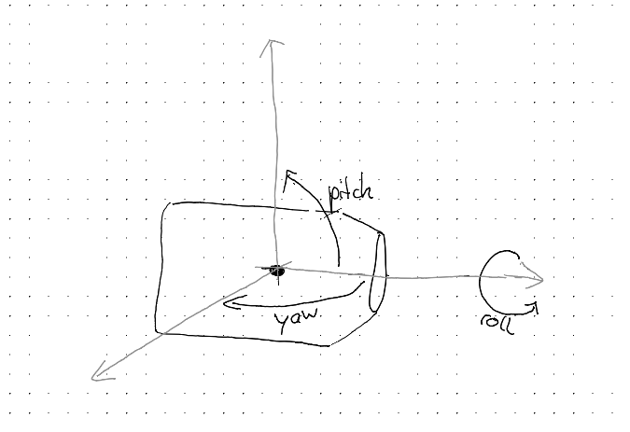
- Yes, we receive data with the test code on the ground station (we use frequency 433.8 MHz)
when they are close together we -46dB, across the room we had values between -52dB and -68dB depending on position and orientation of the antennas.

